Project Design Phase-II
Data Flow Diagram & User Stories

Date | 11 Feb 2026
Team ID | LTVIP2026TMIDS83762
Project Name | LearnHub: Your Center for Skill Enhancement
Maximum Mark | 4 Marks

Data Flow Diagrams:
LearnHub connects students, teachers, administrators, and the database to provide structured and secure online learning. It collects user input (registration, login, enrollment), processes it through backend APIs, stores and retrieves data from MongoDB, and delivers course content, progress updates, and certificates in real time.
  - User interactions are managed through a React-based interface.
  - Requests are sent to the Express backend via REST APIs.
  - Authentication is validated using JWT middleware.
  - Course, user, payment, and enrollment data are stored in MongoDB.
  - Progress tracking updates completed sections dynamically.
  - Certificates are generated using PDFKit and delivered to the user.

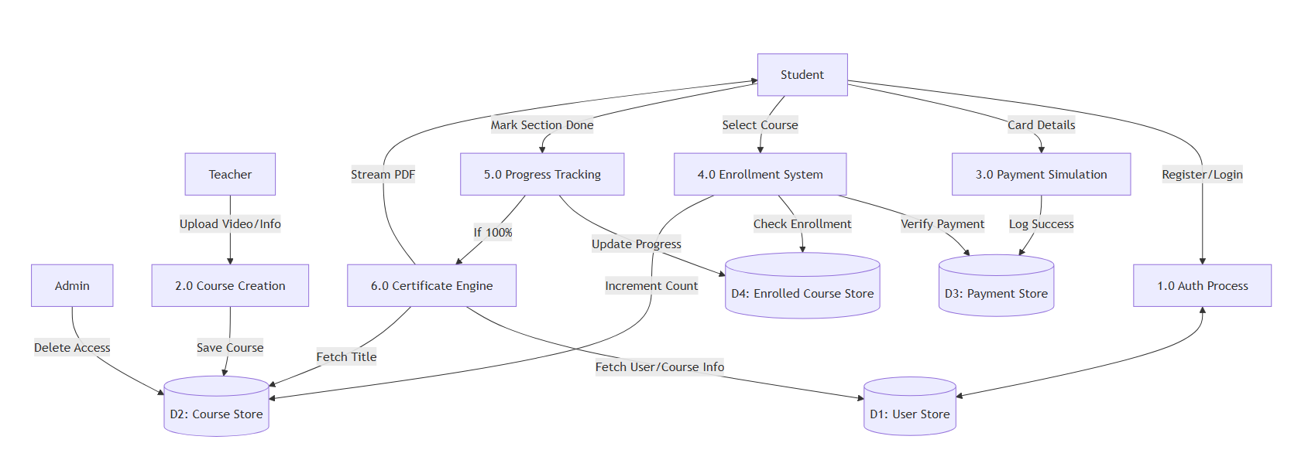

User Stories
- Students want structured online courses with secure access, progress tracking, and certificates to improve their skills.
- Teachers want an easy-to-use platform to upload videos, manage courses, and track student enrollments.
- Administrators want full control over system management, course moderation, and secure user access.

User Type | Functional Requirement (Epic) | User Story Number | User Story / Task | Acceptance criteria | Priority | Release
Student | Registration | USN-1 | As a student, I want to register with name,  email, and password. | User can successfully create an account and receive confirmation. | High | Sprint-1
Student | Login | USN-2 | As a student, I want to log in securely using email and password. | JWT token generated and access granted. | High | Sprint-1
Teacher | Course Management | USN-3 | As a teacher, I want to create and upload courses with videos. | Course saved and visible in course list | High | Sprint-2
Student | Enrollment | USN-4 | As a student, I want to enroll in a course after payment. | Enrollment allowed only after successful payment. | High | Sprint-3
Student | Progress Tracking | USN-5 | As a student, I want to track completed course sections. | Completed sections stored and displayed correctly. | High | Sprint-3
Student | Certification | USN-6 | As a student, I want to download certificate after completing course. | Certificate available only after all sections complete. | High | Sprint-4
Admin | Course Control | USN-7 | As an admin, I want to delete inappropriate courses. | Only admin role can delete courses. | Medium | Sprint-2
Administrator | Security | USN-8 | As a administration, I want role-based access control. | Unauthorized users cannot access restricted routes. | High | Sprint-1

